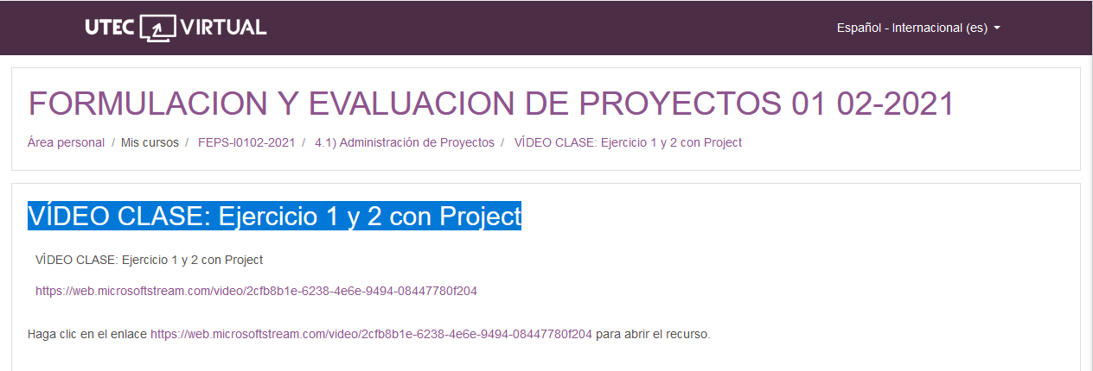

<https://web.microsoftstream.com/video/2cfb8b1e-6238-4e6e-9494-08447780f204?referrer=https:%2F%2Fuv.utecvirtual.edu.sv%2F>